Repetitive Rhyme
Here’s a focused explanation of:

🔁 What is Repetitive Rhyme
# Source: Chatgpt (GPT-4-turbo) at [8/2/2025]
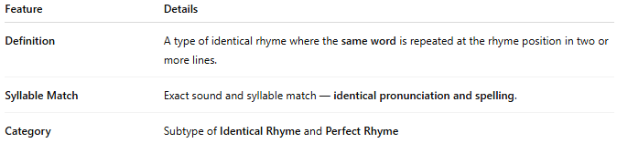
Feature | Details
Definition | A type of identical rhyme where the same word is repeated at the rhyme position in two or more lines.
Syllable Match | Exact sound and syllable match — identical pronunciation and spelling.
Category | Subtype of Identical Rhyme and Perfect Rhyme

📝 Example:
# Source: Chatgpt (GPT-4-turbo) at [8/2/2025]
She said she'd wait until the end,
But never told me when the end
Here, “end” is repeated at the end of both lines — exact match.

🎭 Effect in Poetry:
# Source: Chatgpt (GPT-4-turbo) at [8/2/2025]
- Emphasizes a repeated idea, theme, or emotion
- Creates an echoing or meditative tone
- May suggest finality, obsession, or cyclical thought

⚠️ Common Pitfall:
# Source: Chatgpt (GPT-4-turbo) at [8/2/2025]
- Overuse can feel lazy or uninspired unless it serves a deliberate poetic function (e.g., repetition for rhythm or emphasis).

